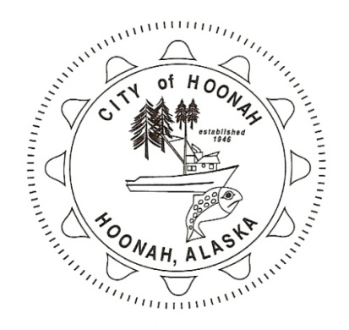
City of Hoonah_______________________________________________
P.O. Box 360 Hoonah, AK 99829 (907) 945-3663 Fax (907) 945-3445

When a person is diagnosed with COVID-19, the Public Health Nurse, Nancy Snyder, will call and interview them. From that discussion, she will determine their resolve date. That date means they will need to isolate through that date. As an example, if they are diagnosed on 9/30/21, they are in isolation until October 1st.

They DO NOT need to test negative after the isolation period.

The following is the CDC guidance criteria used to determine when a person is able to be safely removed from home isolation after a COVID -19 infection:
Persons with COVID-19 symptoms and were directed to care for themselves at home may discontinue isolation under the following conditions:
-at least 10 days have passed since symptoms first appeared
AND
-at least 24 hours have passed since recover defined as resolution of fever without the use of fever-reducing medications and improvement of symptoms
AND
-symptoms (e.g., cough, shortness of breath) have improved

The diagnosed patient may request a letter stating the release date from the State of Alaska, Division of Public Health nurse, Nancy Snyder at 465-1496 or nancy.snyder@alaska.gov.

